**Report 2**

**Name of the Experiment**: FORTRAN & C programming on IF-ELSE statement for Attendance Calculation

**Submission date**: 13 October 2022

Problem:

In CUET, students are usually getting attendance marks (based on the credit) for attending the class. Marks distribution of the attendance are given below:

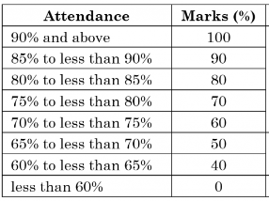

Based on the table, write a program in FORTRAN and C to calculate the attendance marks for 1.5 credit course. Output of the program will show:

1. Student ID
2. Student name
3. Course Credit
4. Marks